**Engineering Project Detailed Research Plan**

**Please complete the information/questions begun/seen below in red ink. Save this document to your computer, and add a printed hard copy to your application.**

**Date: 11/10/2020**

**Student Name: Ananya Mehta**

**Project Title: A more efficient disaster relief system**

Parts of the generic engineering project are listed below with descriptions to the students in the boxes. Students may provide a detailed research plan by describing their specific project in response to each box below.

**Engineering Goal**: PROBLEM BEING ADDRESSED: All engineering projects solve a problem or fill a need. This goal should be a simple statement that describes the product being designed, the customer it is for and the problem or need it satisfies. Example” “The goal is to design a solar powered lawn mower for inexpensive automated lawn care for homeowners”

**My Project Goal i**s:

The design and construction of a disaster relief app that communicates needs from victims to the disaster relief agencies without connection.

**Design Criteria:** Design criteria define the product’s required performance . Examples: “ It will have a minimum speed of 10 KPH”, The output will be within 15% of the mean of the experimental data”. “It must withstand 15 repetitions of a 10N impact” The International System of units (SI) required.

**My Project Design Criteria are the following:**

Defines a standard way for people to communicate their emergency requirements, like food, water, etc. in less than 200 bytes of data

The tracker device should be able to collect emergency needs from 10 houses in 250 meters, under 1 minute.

The tracker device should be able to communicate with 80% of the tag devices with or without line of sight.

The tracker and tag devices should be able to communicate without internet or cell phone connection.

**Constraints: Constraints are factors that limit the engineer’s flexibility such as size, cost, and time limitations. Examples: “It must fit in a box no larger than 10x20x50 cm” “The maximum cost is $50” “The software must run in real time on a Raspberry Pi”**

**My Project Constraints are the following:**

A tag device will be enabled through an app on victim’s smartphones which should have at least 30% charge left.

Both the tag and tracker devices should have Bluetooth support. They do not need to have cell phone or internet connection.

Should be able to prototype the system within 6 weeks.

**Provide your chosen design. For hardware, provide a sketch. For software, provide a flowchart. Indicate the components you will develop, and the libraries you are using.**

**My Project Design is shown below: insert photos, diagrams, or illustrations below.**

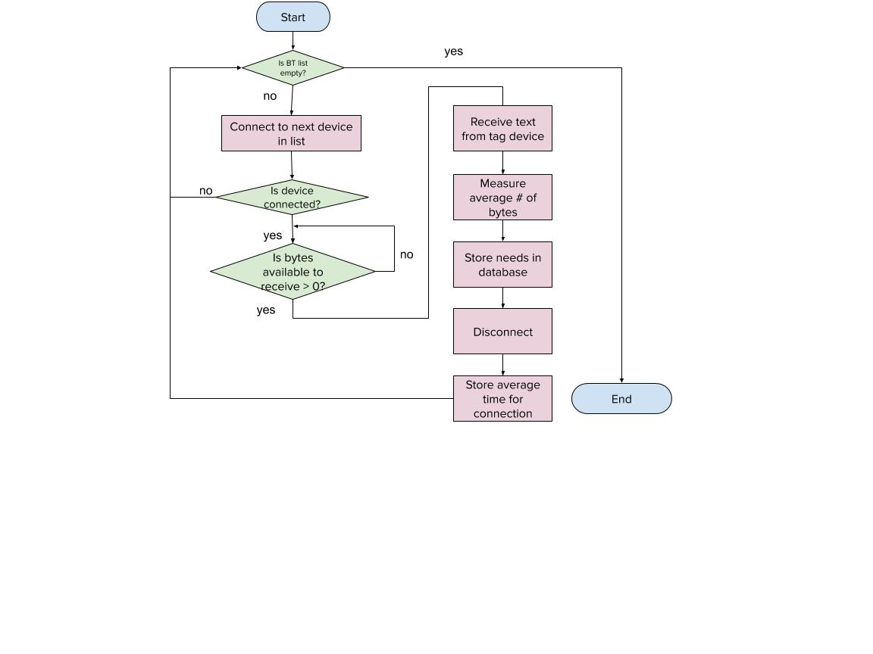

**Test and evaluate your prototypes against the design criteria listed above to show how well the product meets the need/goal. Provide a test plan describing how you will test the design criteria and constraints you listed above., How will you analyze the data? If the product requires human testing please fill out and append https://science-fair.org/wp/wp-content/uploads/2015/10/Research-Plan-Human-Participants.docx**

**I test and analyze my prototypes using the following methods:**

My testing procedures have been listed below:

**Open air and line-of-sight with tracker (3 trials)**

Place phones in your backyard (if you don't have a big one, go to a park).

Fill out the information on each tag device (address, and random needs).

Walk around next to the phones with the tracker phone.

Record Results.

**Open air and no line-of-sight with tracker (3 trials)**

Place phones in your backyard (if you don't have a big one, go to a park).

Fill out the information on each tag device (address, and random needs).

Hide behind something (such as a thick tree or a shed) with the tracker phone.

Record Results.

**Enclosed space and no line-of-sight with tracker (3 trials)**

Place phones in your backyard (if you don't have a big one, go to a park).

Fill out the information on each tag device (address, and random needs).

Place the phones inside your house, and stand outside (make sure that there are no open doors or windows close-by.

Record Results.

**Bibliography: List at least five (5) major references (e.g. science journal articles, books, internet sites & dates of review) from your literature review. If you plan to use vertebrate animals, one of these references must be an animal care reference.**

Content Development Team. “Bluetooth Communication Using MIT App Inventor.” Robo India. 19 May 2019. 4 October 2020. <https://www.roboindia.com/tutorials/bluetooth-communication-mit-app-inventor/>.

BRIGHT SIDE. “How Bluetooth Works.” Youtube. 4 July 2019. 4 October 2020. <https://www.youtube.com/watch?v=jzxZUJmOu3o>

MIT. “MIT App Inventor” MIT app inventor | Explore MIT app inventor. 2012. 3 October 2020. <http://ai2.appinventor.mit.edu/>

KYEM Team. SAR Field Search Methods. Kentucky Emergency Management. 2020. 14 December 2020. <https://kyem.ky.gov/Who%20We%20Are/Documents/SAR%20Field%20Search%20Methods.pdf>

“Sending and Receiving Data with HC-05 - MIT App Inventor.” Robo India || Tutorials || Learn Arduino || Robotics, Content Development Team, 14 June 2019 <https://roboindia.com/tutorials/sending-receiving-with-hc05-mit-app-inventor/>